Room Sense Live
Test jokes with a live AI audience and see how different crowds react to the same material


Build with Gemma: Humor Genome NYC

Hackathon Writeup · Jul 3, 2026
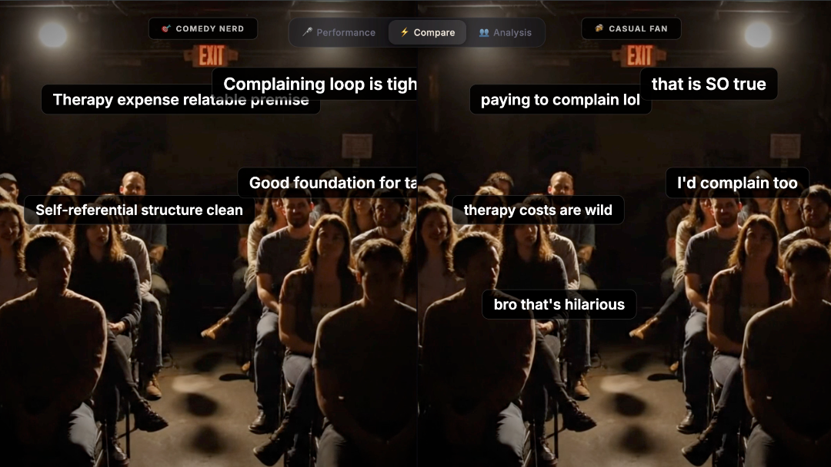
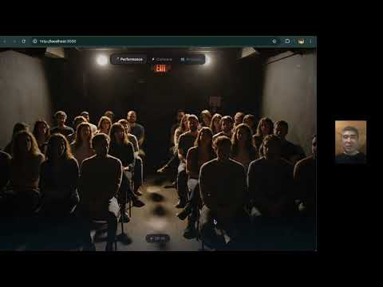

Room Sense Live is a sample Humor Genome NYC concept adapted from an existing AI performance-lab project. The original prototype used Gemini Live for real-time audio interaction. For this hackathon, the same idea can be reimagined with Gemma: helping comedians understand how their material might land with different audiences.
The idea is simple: instead of practicing a joke into silence, a comedian can test a set in front of a simulated audience. A Gemma-based version could receive the performer’s material as text, transcript, notes, or structured input, analyze the joke structure and performance context, and generate reactions from different audience personas. One persona might reward sharp wordplay, another might respond more to personal storytelling, and another might be skeptical of edgy premises or unclear setups.
The goal is not to replace real audiences. Comedy still depends on live rooms, timing, risk, and human connection. Room Sense Live is meant to make the feedback loop faster before a comedian gets on stage. It gives performers a place to test premises, compare versions, and notice where a joke may be confusing, too long, too predictable, or surprisingly strong.
A Gemma-based version can support several modes:
- Performance Mode lets a comedian paste or perform a short set and receive simulated audience reactions such as laughs, silence, confusion, surprise, or applause.
- Compare Mode runs the same joke or set through multiple audience personas so the comedian can see how different crowds might interpret the same material.
- Analysis Mode breaks down the set into setup, premise, escalation, turn, punchline, callback, topic, tone, and audience fit. The comedian can ask why a persona reacted a certain way and what change might make the joke land better.
This concept fits Humor Genome NYC because it treats humor as something more than text generation. It explores timing, context, audience expectation, joke structure, and performance feedback. A strong Gemma-based version would show a working demo, explain where Gemma is used, include sample jokes or transcripts, and honestly describe where the model succeeds or fails.
Room Sense Live is one possible direction for the hackathon: a creative tool that helps comedians rehearse, reflect, and experiment before bringing material to a real room.
Because this sample is an app-style project, the code is shared as a GitHub repo. Notebook-style submissions are also welcome, especially for projects that are easier to explain through examples, prompts, data, or analysis.
Author

Michi Yamamoto
michi883
Share
Competition Prize Track
Main Track

Project Links

GitHub - michi883/room-sense-live
https://github.com/michi883/room-sense-live

github.com

License
This Writeup has been released under the Attribution 4.0 International (CC BY 4.0) license.

Citation
Michi Yamamoto. Room Sense Live. https://www.kaggle.com/competitions/humor-genome-nyc/writeups/new-writeup-1783098817721. 2026. Kaggle

